

Trinity International College

(Under the affiliation of Tribhuvan University)

Dillibazar, Kathmandu, Nepal

Tally Lab Assignment 4

Submitted to:

Sharmila Bhattarai

Department of Computer Science and Information Technology

Trinity International College

By: Rujen Maharjan

Roll No: 15

Semester: 2nd

**Inventory Accounting:**

Inventory accounting is the valuation of inventoried goods that a business has not yet sold to its customers. The inventory of a business can include goods, raw materials and other products that the business buys, manufactures and stores to sell to its customers. The goods in the inventory are part of the assets of the organization. In a balance sheet report, businesses include their inventories as their current asset at the prices at which they purchased them. After they sell the inventory, the companies can remove its cost entry from the inventory account and make entries in the cost of goods sold and product revenue accounts. The profit-making ability of a business typically correlates with its inventory. Therefore, it's necessary to monitor it and keep it in balance.

**Stock Groups:**

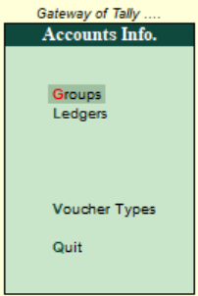Stock Groups in Inventory are similar to Groups in Accounting. They are helpful in the classification of Stock Items. You can group Stock Items under different Stock Groups to reflect their classification based on some common features such as brand name, product type, quality, etc. Grouping enables you to locate the items easily and report their details in statements.

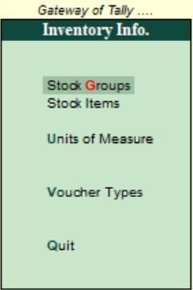

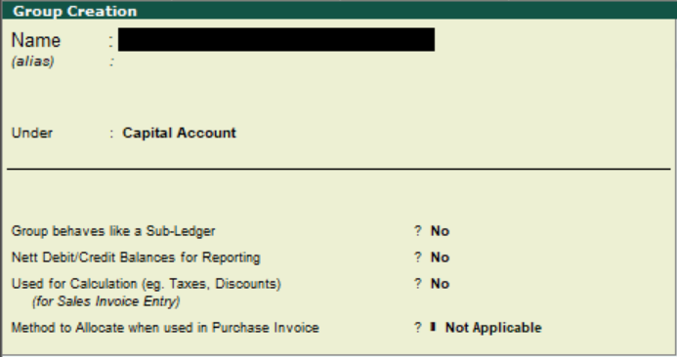

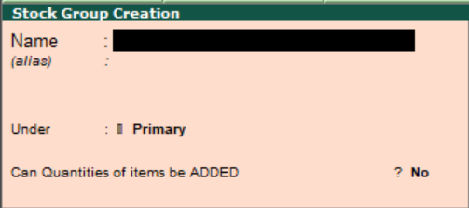

**Stock Group Creation:-**

* Go to **Gateway of Tally**.
* Click on **Inventory Info.**
* 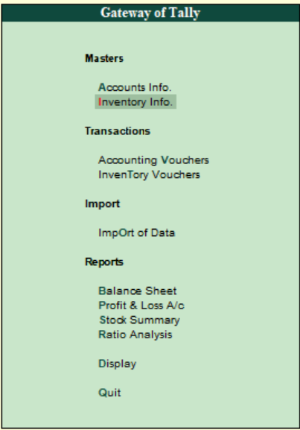Click on **stock** **groups**.
* 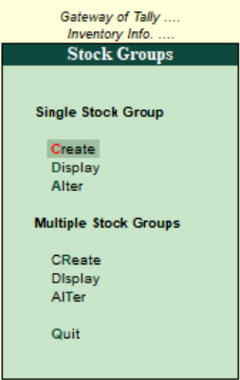Then, create a stock group

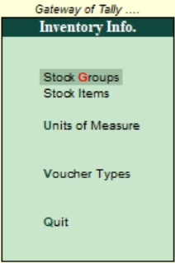

**To create a stock group.**

1. Enter the **Name of the Stock Group** to be created.

1. Enter **Alias** (additional name) apart from primary name [if required]**.**
2. Specify whether it is a primary group or a sub-group of another group in the field **under,** by selecting from the list.
3. Press **Alt + C** to create a parent group, if you do not have it in the list.

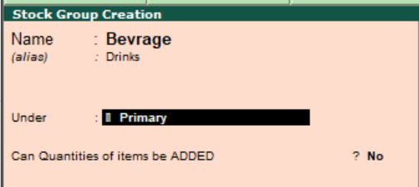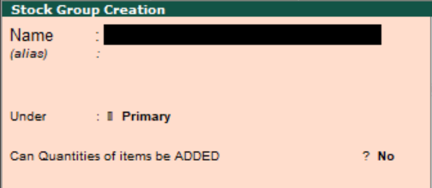

**Different Stock groups of Rujen PVT LTD.**

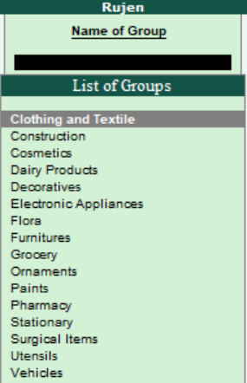

**Units of Measures:**

A unit of measure is a standardized quantity of a physical property, used as a factor to express occurring quantities of that property. Under which all transactions must be consistently recorded using the same currency. For example, a business maintaining its records in the United States would record all of its transactions in U.S. dollars, while a Nepalese company would record all of its transactions in NPR.

**Creating Unit of Measure.**

* Go to **Gateway of Tally.**



* Click on **Inventory Info**.
* 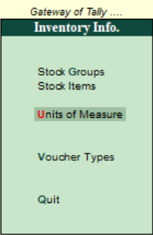Click on **Units of Measure.**

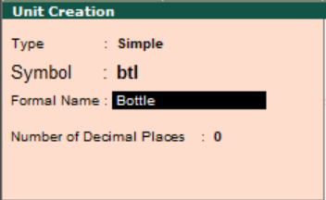

The unit of measure are created as:

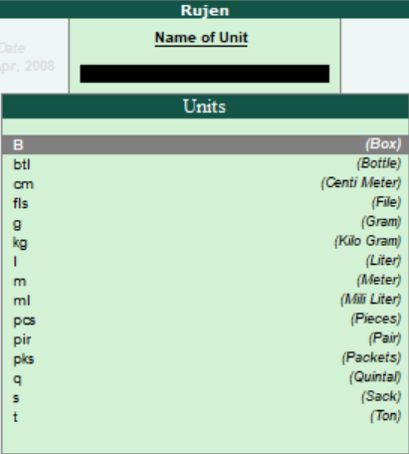

**Stock Items:**

Stock Item refers to goods that you manufacture or trade. It is the primary inventory entity and is the lowest level of information on your inventory. Items in the inventory transaction are similar to ledgers being used in accounting transactions. Therefore, stock items are important in an inventory just as ledgers are important in accounting.

**Stock Items Creation**

* Go to **gateway of tally**.
* Click on **inventory info.**
* 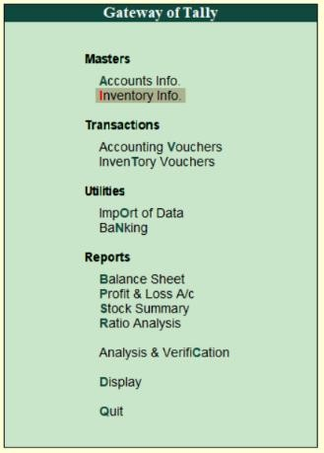Click on **Stock Items.**
* 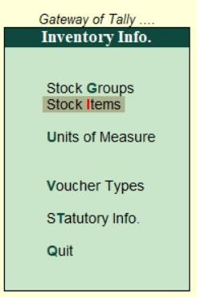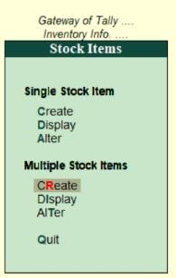Click on **Multiple Stock Items.**

**To create a Stock Item in different Inventory Head.**

* Specify the **Name of the Stock Item**.
* Specify the **Alias name of Stock Item (if required).**
* The field **Under** will show the **List of Groups**. Here you can select the Stock Group to which the Stock Item belongs. By default, Primary Stock Group appears in this field.

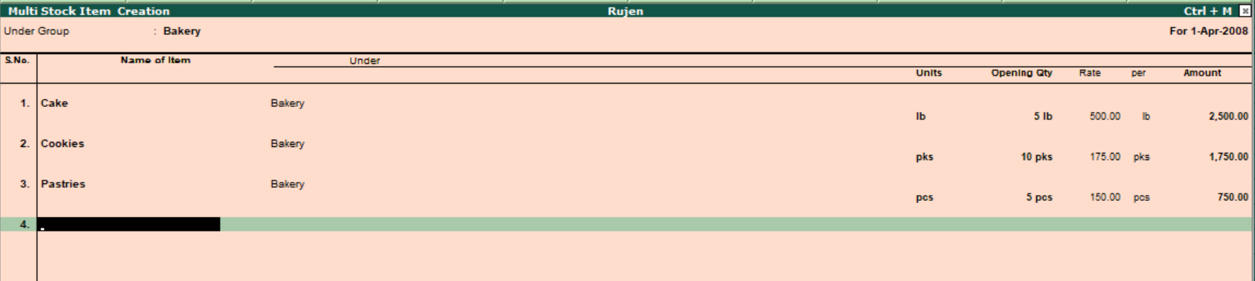

**Different stocks items of Rujen PVT LTD.** 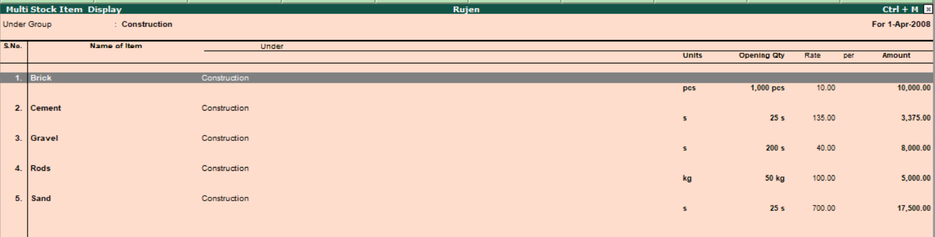

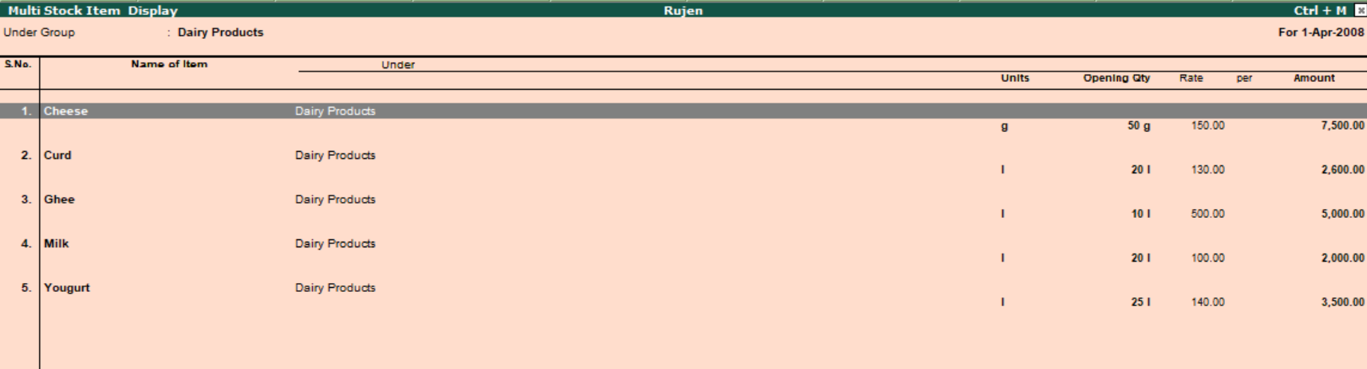

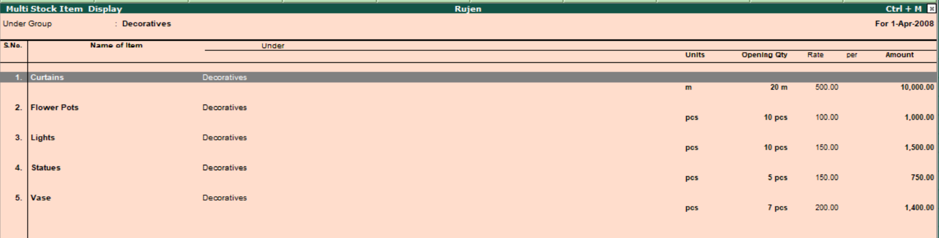

**Inventory Vouchers:**

Inventory Vouchers performs the same function in the inventory system as accounting voucher do. They are the means by which you enter transactions relating to the Inventory. The vouchers record transactions relating to the issue and receipt of stock, the transfer of stock between good owns, and physical stock adjustments. The following inventory vouchers are available:

* **Purchase Order (alt+f4)**
* **Stock Journal (alt+f7)**
* **Sales Order (alt+f5)**
* **Delivery Note (alt+f8)**
* **Rejections Out (alt+f6)**
* **Receipt Note (alt+f9)**
* **Rejection In (ctrl+f6)**
* **Physical Stock (alt+f10).**

**Purchase order (alt+f4):** Purchase order has to be made in the books of the company to assist them in checking whether the goods have been received or not. The purchase order number can be used as a reference. For example, the company wishes to place an order with the supplier for some goods.

**Sales Order (alt+f5):** When the order is received from a customer for goods to be supplied, the Items, quantities, date of delivery, etc., details are given with Sales Order Number. Laterwhen these goods are delivered, this Sales Order is tracked for the order Detailseither in the delivery note or in the sales invoice.

**Rejections Out (alt+f6):** A rejection out entry is passed to record the rejected goods. This is a pure inventoryvoucher. For example: we have purchased some goods and have rejected a part of it. Description Records rejected stock details returned to suppliers. Details Recorded Ledger account, Suppliers name and address, Order details, Stock item, tracking details, Goods owned, Quantity, Rate, Amount, and Narration.

**Rejections In (ctrl+f6)**: A rejection in entry is passed to record the rejected goods. The Rejection In entry is a pure inventory voucher. For example: a costumer has rejected goods that was sold earlier. ) Description Records rejected stock details received from customer. Details Recorded Ledger account, Customer name and address, Order details, Stock item, Tracking

**Stock Journal (alt+f7):** To record the consumption of goods there is no need for entries in both sides of the voucher. Such entries can be entered in a stock journal voucher. For example: the company transfers the items of stock from the warehouse to shop.

**Delivery Note (alt+f8)**: Goods that are being delivered to a customer in a Delivery Note Voucher. Records delivery of new stock to customers. Details Recorded Reference, Ledger account, Suppliers(if supplementary details are set to yes in f12: Delivery Note Configuration)then, name and address, Order and dispatch details, Name of stock item, Order details, Goods owned, Quantity, Rate(optional),Amount(optional), Narration.

**Receipt Note (alt+f9):** Goods that are received from the supplier are recorded in a Receipt Note (GoodsReceipt Note – GRN) voucher. Records receipt of new stock from supplier. Details Recorded Reference, Ledger account, Suppliers(if supplementary details are set to yes in f12: Delivery Note Configuration)then, name and address, Name of stock item, Order details, Goods owned, Quantity, Rate(optional), Amount(optional),Narration.

**Physical Stock Voucher (alt+f10**): It consider the stock available based on the entry made in a physical stock voucher. For example: on conducting a stock, the company finds a discrepancy between the actual stock and the recorded stock figure.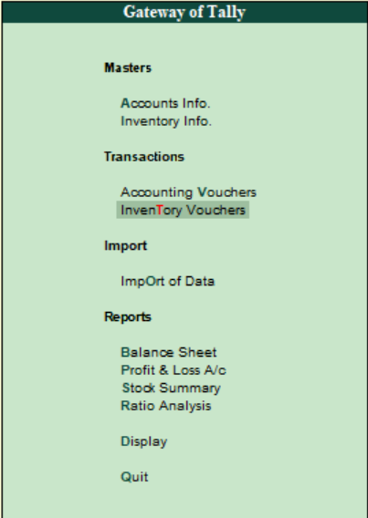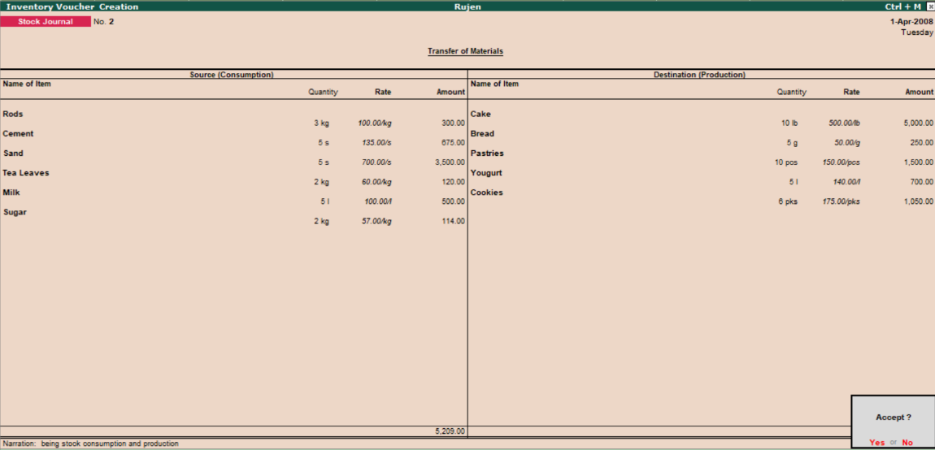

**Creating inventory voucher:**

**Entering different consumption and production of company.**

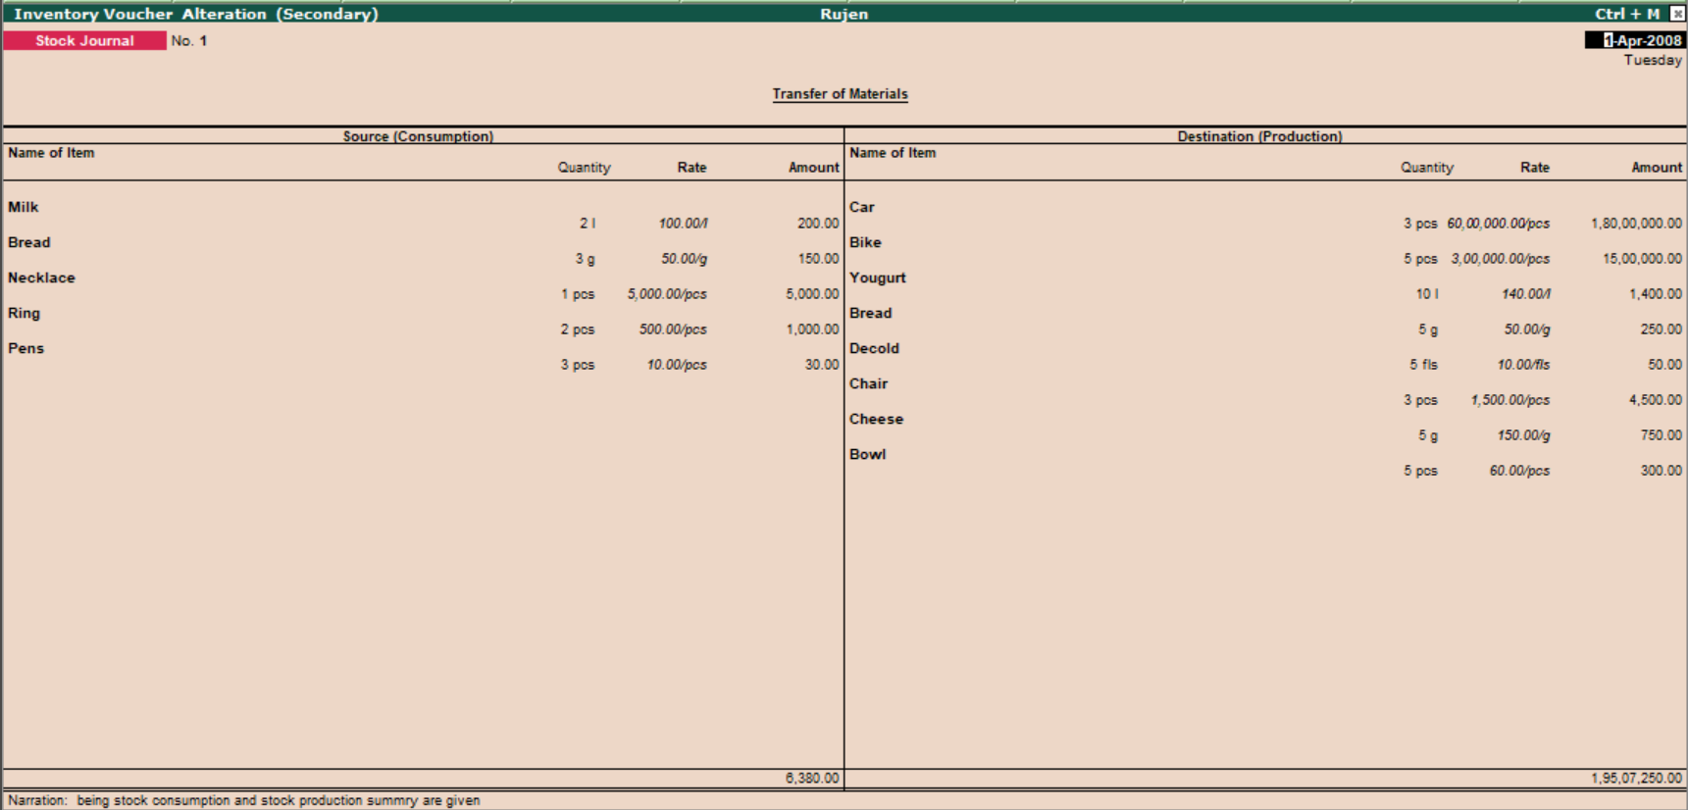

**Cash and bank book of Rujen PVT LTD.**

A cash book is a financial journal that contains all cash receipts and disbursements, including bank deposits and withdrawals. Entries in the cash book are then posted into the general ledger.

**Path:** Gateway of Tally>> Display Menu>> Account Books >> Cash/Bank Summary

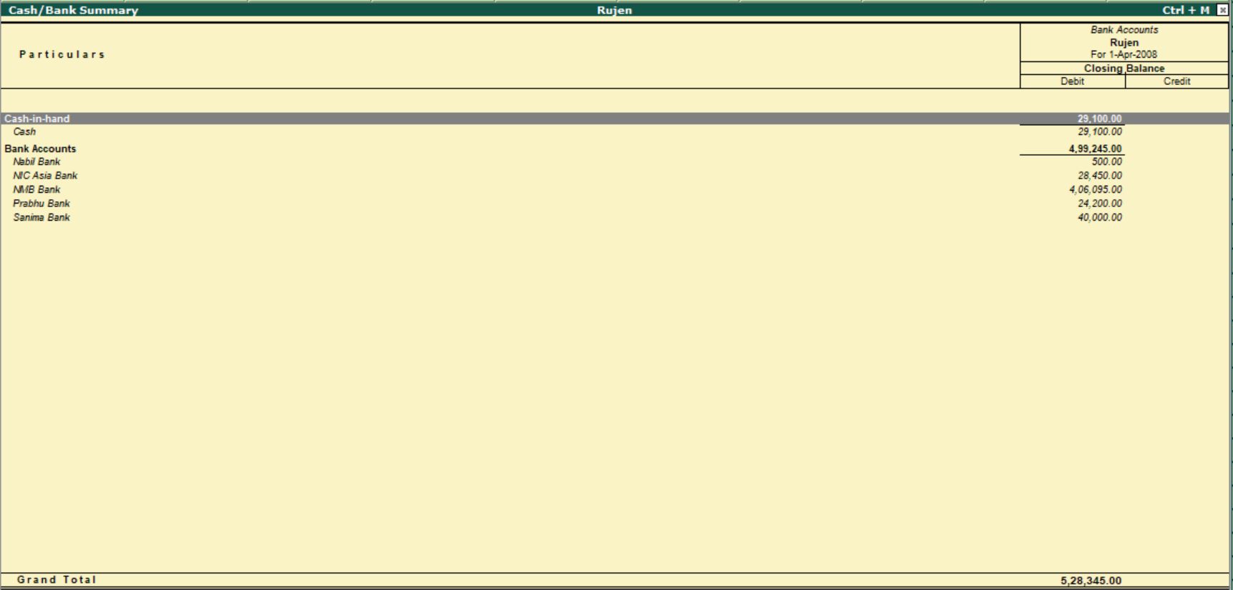

**Sales register of April month in Rujen PVT LTD.**

The sales register is the book in which we keep a record of all credit transactions connected to the Sale of goods. The Sales Account is the ledger account where all business transactions involving the Sale of goods for money or credit are recorded. The balance of the sales register does not affect the Financial Statement of the business.

**Path:** Gateway of Tally --> Display Menu --> Account Books --> Sales Register

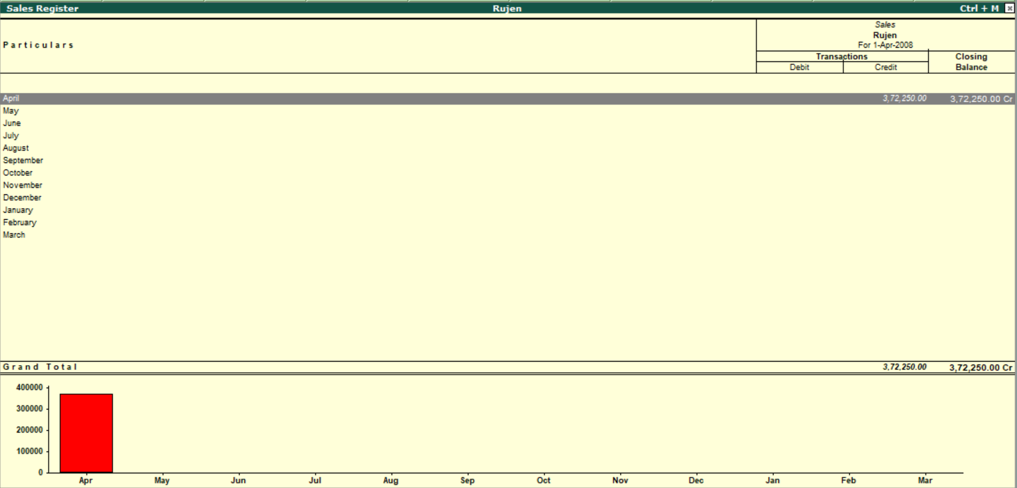

**Statistics of accounts**

**Path:** Gateway of Tally --> Display Menu --> Statements of Accounts --> Statistics

